**Software Requirements Specification**

**For project LearnHub**

**Prepared by:**

**Trần Tấn Đạt**

**Lê Hữu Huy**

**Nguyễn Phương Tâm Tâm**

**Vũ Mạnh Khải**

**Lê Đức Nam**

**Trương Minh Hoàng**

**November 11, 2024**

**Table of contents**

1. **Introduction** 1.1 Background 1.2 Business opportunity 1.3 Business Objectives 1.4 Vision Statement
2. **Overall Description** 2.1. Product Perspective 2.2. User Classes and Characteristics 2.3. Operating Environment 2.4. Design and Implementation Constraints 2.5. Assumptions and Dependencies
3. **System Feature** 3.1 Use case 3.2 Use Case Specification
4. **Data Requirements** 4.1 Logical Data Model 4.2 Data dictionary
5. **External Interface Requirements** 5.1 User interfaces 5.2 Software interface
6. **Quality Attributes** 6.1 Usability Requirements 6.2 Performance Requirements 6.3 Security Requirements 6.4 Availability Requirements 6.5 Robustness Requirements 6.6 Wireframe 6.8 Prototype
7. **Swimlane**
8. **State machine**
9. **Sequence diagram**
10. **Class diagram**

**3. System Feature**

**3.1 Use case**



**3.2 Use Case Specification**

* **Use case for View Number of Student(Truong Minh Hoang)**

### 

|  | **UC-1 View Number of Student** | | |
| --- | --- | --- | --- |
| **Created By:** | **Truong Minh Hoang** | **Date Created:** | **20/01/23** |
| **Primary Actor:** | **Course Manager** | **Secondary Actors:** | **None** |
| **Description:** | **The Course Manager navigates to the dashboard screen and clicks on the "Student List Display" section. Within this section, the manager chooses one of the courses they have created, which is listed on the screen. Subsequently, the Course Manager can view detailed information, including the number of students enrolled in each course, along with background information about each student and their respective course registration dates.** | | |
| **Trigger:** | **A Course Manager expresses the desire to observe the student count in each of their courses.** | | |
| **Preconditions:** | **PRE-1. Course Manager accessed LearnHub platform on the Internet.****PRE-2. Course Manager logged into LearnHub platform.** | | |
| **Postconditions:** | **POST-1: The Course Manager reviews the student count in each of their courses, accompanied by additional information such as student background details and course registration dates.** | | |
| **Normal Flow:** | **1.0 View Number of Student****Course Manager accesses the LearnHub platform on the Internet.****2. Course Manager logs into LearnHub platform.****3. Course Manager goes to his/her dashboard screen. He/she clicks on the student list display section and selects one of the courses he/she created that is being displayed on the screen.****4. LearnHub will display the number of students in the selected course with accompanying information such as student background information and course registration date.** | | |
| **Alternative Flows:** | **None** | | |
| **Exceptions:** | **11.0.E1 No student registers; displays an error message with the content "There is no student registers your course.”.** | | |
| **Priority:** | **High** | | |
| **Frequency of Use:** | **Approximately 10 users, average of one usage per day.** | | |
| **Business Rules:** | **Only Course Manager with an active LearnHub account can access the student view section.** | | |
| **Other Information:** |  | | |
| **Assumptions:** |  | | |

* **Use case for** Buy a Course **(Le Duc Nam)**

### 

| **ID and Name:** | **Buy a Course** | | |
| --- | --- | --- | --- |
| **Created By:** | **Le Duc Nam** | **Date Created:** | **20/01/23** |
| **Primary Actor:** | **Student** | **Secondary Actors:** | **None** |
| **Description:** | **A student accesses LearnHub – skill course platform, from everywhere, views the home page which contains every skill course categories or search for a course filter by categories, prices, levels, select a course and buy course by transfer course’s price to LearnHub account.** | | |
| **Trigger:** | **A student indicates that he wants to buy a course** | | |
| **Preconditions:** | **PRE-1. Student is logged into LearnHub.** | | |
| **Postconditions:** | **POST-1. Course order is stored in LearnHub with a status of “Accepted”.****POST-2. Student can start the course anytime** | | |
| **Normal Flow:** | | **1.0 Course Purchase Process****1. The student requests to view all courses available on the LearnHub platform, including course names, descriptions, learning objectives.****2. LearnHub displays all courses categorized by categories, prices, and sorting options like newest or oldest.****3. The student selects a specific course to view detailed information.****4. The student has the option to either order the course immediately or add it to their shopping cart.****5. LearnHub shows the contents of the cart, including individual course prices, and calculates the total price, including taxes and additional charges.****6. The student can either confirm the course order or choose to continue shopping, returning to step 2.****7. The student specifies the preferred payment method for the selected course.****8. LearnHub confirms the acceptance of the order and processes the payment.****9. LearnHub sends an email confirmation to the student, providing details of the order and the total price.****10. LearnHub stores the student's course information and notifies the course instructor about the new enrollment.** | | --- | | | |
| **Alternative Flows:** | **1.1 Order multiple courses****1. Student asks to order more courses****2. Return to step 1 of normal flow.** | | |
| **Exceptions:** | **1.0.E1 Payment of Student haven’t update****1. LearnHub informs Student that patment status is not confirm yet.****2a. If Student start complains that they transferred the money then staff will check LearnHub account.****2b. If Student not pay for course then informs that LearnHub have not recieved the money.** | | |
| **Priority:** | **High** | | |
| **Frequency of Use:** | **Approximately 300 users, average of one usage per day. Peak usage load for this use case is between 9:00 A.M. and 10:00 A.M. local time.** | | |
| **Business Rules:** | **Order must be checkout with zalo pay or vnpay** | | |
| **Other Information:** |  | | |
| **Assumptions:** |  | | |

* **Use case for** Comment/Rating **(**Trần Tấn Đạt**)**

| ID and Name: | **Comment/Rating** | | |
| --- | --- | --- | --- |
| Created By: | Trần Tấn Đạt | Date Created: | 20/1/23 |
| Primary Actor: | Student | Secondary Actors: | Course Manager |
| Description: | A student accesses the LearnHub from any device with an internet connection, browses through available courses, selects a course of interest, and gains ability to comment and rating the course | | |
| Trigger: | The student logs into the LearnHub | | |
| Preconditions: | **PRE-1:** The student is registered for the course.  **PRE-2:** The student has a valid login to the LearnHub | | |
| Postconditions: | **POST-1:** Student successfully submits comments and a rating for the selected course.  **POST-2:** The LearnHub system captures and stores the student's comments and rating, updating the course's overall feedback metrics in real-time within the learning analytics system. | | |
| Normal Flow: | 1. The student initiates a session by logging into LearnHub.  2. LearnHub's interface displays a comprehensive list of available courses.  3. Upon selecting a specific course, LearnHub dynamically generates and presents the course homepage, which includes modules, lecture videos, reading materials, quizzes, and assignments.  4. As the student navigates through the course materials, LearnHub enables a feature for submitting comments and a rating.  5. The student takes advantage of this feature, providing insightful comments and assigning a rating to the course.  6. LearnHub seamlessly processes and records the submitted comments and rating, updating the course's overall feedback metrics.  7. The learning analytics system, integrated with LearnHub, captures and stores the student's engagement data, including the newly provided comments and rating. | | |
| Alternative Flows: | **Comment/Rating for Multiple Courses**  **Student Expresses Interest in Rating More Courses:**  1. After completing comments and a rating for one course, the student expresses interest in reviewing and rating additional courses.  2. LearnHub facilitates the seamless return to the course list or homepage.  3. The student selects another course and proceeds to provide comments and a rating.  4. This process repeats until the student has reviewed all desired courses.  5. The student can then log out or explore other LearnHub features. | | |
| Exceptions: | **Temporary Unavailability of Comment/Rating Feature for Additional Courses:**  1. If the comment/rating feature for additional courses is temporarily unavailable, LearnHub notifies the student and provides an estimated resolution time.  2. During this period, students can still access other course materials.  3. Upon resolution, the student can resume providing comments and ratings for additional courses. | | |
| Priority: | High | | |
| Frequency of Use: | Approximately 500 users, with varying usage patterns throughout the day. Peak usage is expected during evenings and weekends. | | |
| Business Rules: | Comment have maximum words is 3000  The rating scale is limited to a predefined range (1 to 5 stars). | | |
| Other Information: | 1. Comments and ratings submitted by students are visible to other enrolled students for the same course  2. Students receive notifications within LearnHub when there are responses to their submitted comments or ratings.  3. LearnHub employs a moderation system to identify and address inappropriate or offensive comments. | | |
| Assumptions: |  | | |

* **Use case for** Manage Course **(Vũ Mạnh Khải)**

| **ID and Name:** | **Manage Course** | | |
| --- | --- | --- | --- |
| **Created By:** | **Vũ Mạnh Khải** | **Date Created:** | **20/1/23** |
| **Primary Actor:** | **Course Manager** | **Secondary Actors:** | **None** |
| **Description:** | **This includes adding new courses, updating existing ones, and ensuring the availability of course materials. The administrator also oversees user access and resolves any technical issues related to course content.** | | |
| **Trigger:** | **The Course Manager logs into the E-Learning System.** | | |
| **Preconditions:** | **PRE-1: The Course Manager has a valid login to the E-Learning System.**  **PRE-2: The Course Manager has the necessary permissions for course management.** | | |
| **Postconditions:** | **POST-1: Course information and materials are updated as per the administrator's actions.**  **POST-2: Any technical issues related to course content are addressed promptly.** | | |
| **Normal Flow:** | 1. **The Course Manager logs into the E-Learning System using their valid credentials.** 2. **The E-Learning System authenticates the Course Manager and presents the admin dashboard.** 3. **In the admin dashboard, the Course Manager navigates to the course management section:** 4. **3.1 Selects "Add New Course" to create a new course, providing details such as course name, modules, lecture videos, reading materials, quizzes, and assignments.** 5. **3.2 Chooses "Edit Course" to modify existing course details, including content and availability.** 6. **3.3 Accesses the "Ensure Availability" option to verify the availability of course materials and troubleshoots any technical issues, if identified.** 7. **After making changes, the Course Manager saves the modifications.** 8. **The E-Learning System confirms the successful update, and the administrator logs out or proceeds to other admin functionalities.** | | |
| **Alternative Flows:** | **Course Manager Searches for a Specific Course: If the administrator needs to find a particular course, they can use the search functionality.** | | |
| **Exceptions:** | ***1.0.* *E1 Unavailability of* Course Manager *Functionality:***  ***If the* Course Manager *features are not available due to maintenance or technical issues, the system informs the* Course Manager *and provides an estimated resolution time.*** | | |
| **Priority:** | **High** | | |
| **Frequency of Use:** | **Course Manager activities may vary, with peak usage during course creation and maintenance periods.** | | |
| **Business Rules:** | **Course Editing and Versioning: Course editing is allowed, with a prerequisite that any changes must be thoroughly reviewed and approved. Old courses remain unchanged for existing students, preserving their access to original learning materials, while new enrollees have access to updated resources in the modified version.** | | |
| **Other Information:** | **1. User Feedback Integration:**  **The E-Learning System actively gathers and integrates user feedback to enhance the overall user experience and address specific user needs.**  **2.Collaborative Content Management:**  **The system supports collaborative content creation and management, enabling multiple Course Manager to work on course materials simultaneously.**  **3. User Support System:**  **A comprehensive user support system is in place to assist both administrators and students with any inquiries, technical issues, or usage-related questions.** | | |
| **Assumptions:** |  | | |

* **Use case for** View Profit of all Course **(**Nguyễn Minh Tuấn**)**

| ID and Name: | **View Profit of all Course** | | |
| --- | --- | --- | --- |
| Created By: | Nguyễn Minh Tuấn | Date Created: | 20/01/23 |
| Primary Actor: | Course Manager | Secondary Actors: | None |
| Description: | The Course Manager accesses the LearnHub Admin Dashboard from any device with an internet connection, navigates to the financial analytics section, and gains the ability to view the profit generated by all courses. | | |
| Trigger: | The Course Manager logs into the LearnHub Admin Dashboard. | | |
| Preconditions: | PRE-1. The Course Manager has a valid login to the LearnHub Admin Dashboard.  PRE-2. Financial data for all courses is up-to-date. | | |
| Postconditions: | POST-1. The Course Manager successfully views the profit data for all courses.  POST-2. The LearnHub system provides accurate financial metrics. | | |
| Normal Flow: | |  | | --- |   1. The Course Manager initiates a session by logging into the LearnHub Admin Dashboard.    2. LearnHub's Admin Dashboard interface displays various sections, including analytics.      3. The Course Manager navigates to the financial analytics section.    4. Within the financial analytics section, the Course Manager selects the "View Profit of all Courses" option.      5. LearnHub dynamically generates and presents a comprehensive report displaying the profit generated by each course.    6. The Course Manager reviews the report, which includes detailed financial metrics for all courses, such as revenue, expenses, and net profit. | | |
| Alternative Flows: | 1. LearnHub notifies the Course Manager about the unavailability. 2. The Course Manager is allowed to proceed with other non-financial functionalities within the Admin Dashboard. 3. Once the financial data becomes available, the Course Manager is notified, and they can return to viewing the profit data. | | |
| Exceptions: | 1. If there is a temporary unavailability of financial data, LearnHub notifies the Course Manager and provides an estimated resolution time. 2. In case of discrepancies or errors in the financial data, the Course Manager can report the issue to the Admin for investigation. | | |
| Priority: | High | | |
| Frequency of Use: | Monthly, typically at the end of each financial reporting period. | | |
| Business Rules: | 1. The financial data is presented in accordance with the organization's accounting standards. 2. The profit is calculated based on revenue and expenses associated with each course. 3. Only authorized personnel, such as the Course Manager and Admin, have access to view profit data. | | |
| Other Information: |  | | |
| Assumptions: |  | | |

**4. Data Requirements**

**4.1 Logical Data Model**

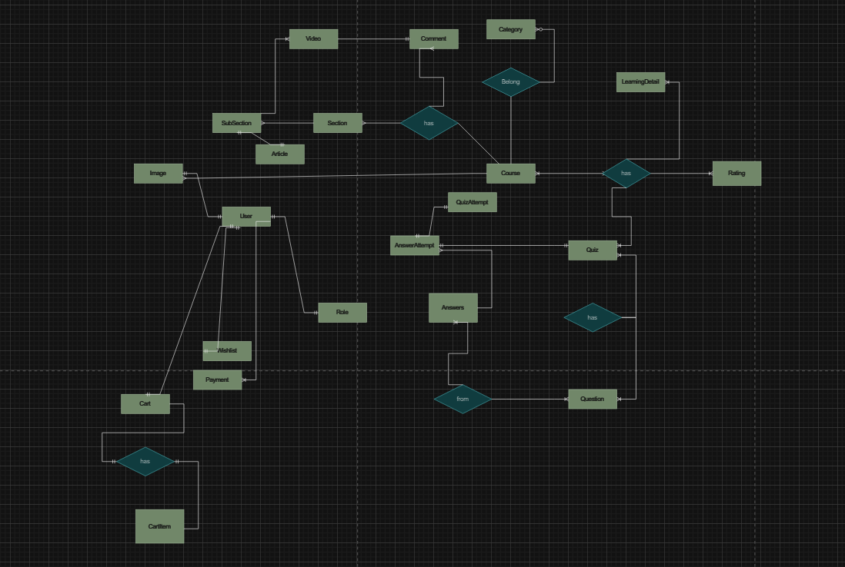

**4.2 Data dictionary**

## 

| **Data Element** | **Description** | **Composition or Data Type** | **Length** | **Values** |
| --- | --- | --- | --- | --- |
| register a course | The "register a course" data element typically refers to information associated with a student's enrollment in a particular academic course.  This data element includes details about the course itself, the student, and any relevant information needed for the registration process | Course Information:  Course Code  Course Title  Instructor  Schedule (day, time, location)  Prerequisites  Credits |  |  |
| create account | Creating an account involves collecting and storing information about an individual or entity to grant access to a system, service, or platform. This data is crucial for personalization, security, and communication purposes. | Personal Information:  -Full Name  -Date of Birth  -Gender  -Address  Contact Information:  -Email Address  -Phone Number  Login Credentials:  -Username  -Password (encrypted) | 50 | Gender: Male, Female, Other  Language: English, Spanish, French, etc. |
| login | Logging in is the process by which a user gains access to a system, service, or platform by providing valid credentials. | Login Credentials:  Username or Email Address  Password | 20 |  |
| userId | Student ID who can view, subscribe, log in, comment | integer | 6 |  |
| course description | A course description is a concise summary of the key aspects of a particular academic course. | Course Title: String  Course Code: Alphanumeric  Instructor(s): String or list of strings  Overview/Summary: String or paragraph | 100 |  |
| course item price | The course item price refers to the monetary cost associated with enrolling in a particular academic course or obtaining specific course-related materials. | numeric, dollars and cents | dd.cc |  |
| create course date | The course creation date is the specific date when an academic course is introduced and officially becomes part of the educational program | date, MM/DD/YYYY | 10 | default = current date if the current time is before the order cutoff time, else the next day; cannot be prior to current date |
| wishlist | A wish list is a collection of items or experiences that an individual expresses a desire to have or achieve | courseId |  |  |
| payment | information about a payment COS accepted for a course | payment amount  + payment method  + transaction number |  |  |
| order cutoff time | the course registration period is a predefined time window when students can sign up for the courses they plan to take during an upcoming academic term or semester. | time, HH:MM | 5 |  |
| course registration period | one menu food item that a Patron requested as part of a meal order | menu food item  + quantity ordered |  |  |
| admin | An admin, short for administrator, is an individual with special privileges and responsibilities related to the control, management, and maintenance of a system, platform, or organization | User Role: String or Enumerated type (e.g., Admin, System Administrator).  Privileges: List of specific permissions or access levels.  Responsibilities: String or list of duties. |  |  |
| admin email | An admin email is the electronic mail address designated for communication related to administrative matters | alphanumeric | 50 |  |
| patron name | name of the employee who placed a meal order | alphabetic | 30 |  |
| payment amount | total price of an order in dollars and cents, calculated per BR-12 | numeric, dollars and cents | dddd.cc |  |
| payment method | how the Patron is paying for a meal he ordered | alphabetic | 16 | payroll deduction, cash, credit card, debit card |
| course management | Course management encompasses the entire lifecycle of a course, from its conception and design to its delivery, assessment, and ongoing improvement. | Course Information: String or structured data.  Enrollment Data: Numeric or Alphanumeric.  Scheduling Information: Date and Time data types.  Grades and Assessments: Numeric or Alphanumeric.  Feedback: String or comments |  |  |
| user management | User management involves the administration and oversight of user accounts within a system. | Usernames/User IDs: Alphanumeric strings or numbers.  Authentication Credentials: Encrypted passwords, biometric data, or other secure means of verifying identity.  Roles/Permissions: Enumerated types or structured data indicating user roles and associated permissions.  User Profiles: String or structured data containing information about each user (e.g., name, contact information). |  |  |

## 

**5. External Interface Requirements**

**5.1 User interfaces**

UI-1: The website will allow complete navigation and selection of furniture items using a mouse alone or in addition to using a mouse and keyboard combination.

**5.2 Software interface**

SI-1: Furniture inventory system

* SI-1.1: Home-furniture will transmit the quantity of furniture ordered to the System through the programming interface.
* SI-1.2: Home-furniture checks the quantity and condition of furniture for customers to place orders

**6. Quality Attributes**

**6.1 Usability Requirements**

* USE-1: The web application shall provide clear and intuitive navigation menus and links to allow users to easily browse through product categories, view product details, and add items to their shopping cart.
* USE-2: The system shall ensure that all text, buttons, and interactive elements have appropriate contrast ratios and font sizes to ensure readability and accessibility for users with visual impairments.
* USE-3: The web application shall support responsive design principles and shall be compatible with a range of devices and screen sizes, including desktops, laptops, tablets, and smartphones.
* USE-4: The system shall provide users with the option to customize their browsing experience, including the ability to filter products by price, category, brand, and other relevant attributes.
* USE-5: The web application shall provide informative and helpful error messages to users in case of form submission errors or invalid input, guiding them on how to correct the issue.
* USE-6: The system shall offer multiple payment options, including credit/debit cards, PayPal, and other popular payment gateways, to accommodate user preferences and enhance convenience.
* USE-7: The web application shall include a user-friendly checkout process with clear steps and progress indicators, allowing users to review their order details, apply discounts, and select shipping options before completing the purchase.
* USE-8: The system shall provide users with the ability to track the status of their orders in real-time, including order processing, shipping, and delivery updates, via email notifications and a dedicated order tracking page.
* USE-9: The web application shall offer comprehensive help documentation and support resources, including FAQs, tutorials, and contact information for customer support, to assist users in resolving issues and inquiries promptly.
* USE-10: The system shall allow users to provide feedback and ratings for products and overall shopping experience, facilitating continuous improvement and enhancing user engagement and satisfaction.

**6.2 Performance Requirements**

* PER-1: The system shall accommodate a total of 500 users and a maximum of 150 concurrent users during the peak usage time window of 10:00 A.M. to 12:00 P.M. local time, with an estimated average session duration of 10 minutes.
* PER-2: 90% of webpages generated by the eFurniture System shall download completely within 3 seconds from the time the user requests the page over a 50Mbps or faster Internet connection.
* PER-3: The system shall display confirmation messages to users within an average of 2 seconds and a maximum of 5 seconds after the user submits information to the system.

**6.3 Security Requirements**

* SEC-1: All network transactions that involve financial information or personally identifiable information shall be encrypted using TLS 1.2 or higher per industry standards.
* SEC-2: Users shall be required to log in to the eFurniture System for all operations except browsing product catalog pages.
* SEC-3: Only authorized administrators shall be permitted to manage user accounts and system configurations, per the RBAC (Role-Based Access Control) model.
* SEC-4: The system shall enforce strong password policies, including a minimum length of 8 characters, with a combination of uppercase letters, lowercase letters, numbers, and special characters.
* SEC-5: The system shall implement rate limiting mechanisms to prevent brute force attacks on login pages, with a maximum of 5 failed login attempts allowed within a 5-minute window.

**6.4 Availability Requirements**

* AVL-1: The e-Furniture shall be available at least 98% of the time between 5:00 A.M. and midnight local time and at least 90% of the time between midnight and 5:00 A.M. local time, excluding scheduled maintenance windows.
* AVL-2: The eFurniture system claims 99.99% annual uptime without problems.
* AVL-3: The e-furniture system requires recovery within 30 minutes from the time of failure.
* AVL-4: The eFurniture system requires a data backup and recovery process in place to ensure recovery after problems.
* AVL-5: The e-furniture system requires the ability to automatically switch to a backup system when the main system fails.
* AVL_6: The eFurniture system requires monitoring and alerts when the system has problems, sent via email or text message,...

**6.5 Robustness Requirements**

* ROB-1: If the connection between the user and the eFurniture System is broken before a new order is either confirmed or terminated, the eFurniture System shall enable the user to recover an incomplete order and continue working on it.
* ROB-2: If a payment transaction fails, the eFurniture System shall notify the user of the failure, provide a clear reason for the failure, refund expenses and vouchers if used, recover, and continue working on an incomplete order.
* ROB-3: If a user's session times out due to inactivity, the eFurniture System shall securely log the user out, preserving the shopping cart contents. Upon re-login, the system should prompt the user to restore the previous session or start a new one.
* ROB-4: The eFurniture system will support 5000 concurrent users without sacrificing performance. In case the system capacity is reached, the platform will display an overload message, store unfinished processes if any, and ask the user to redo the operation later.

**6.6 Wireframe**

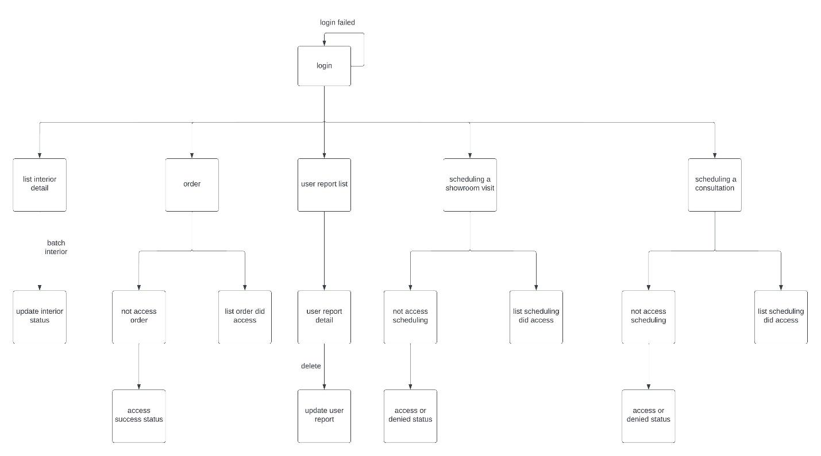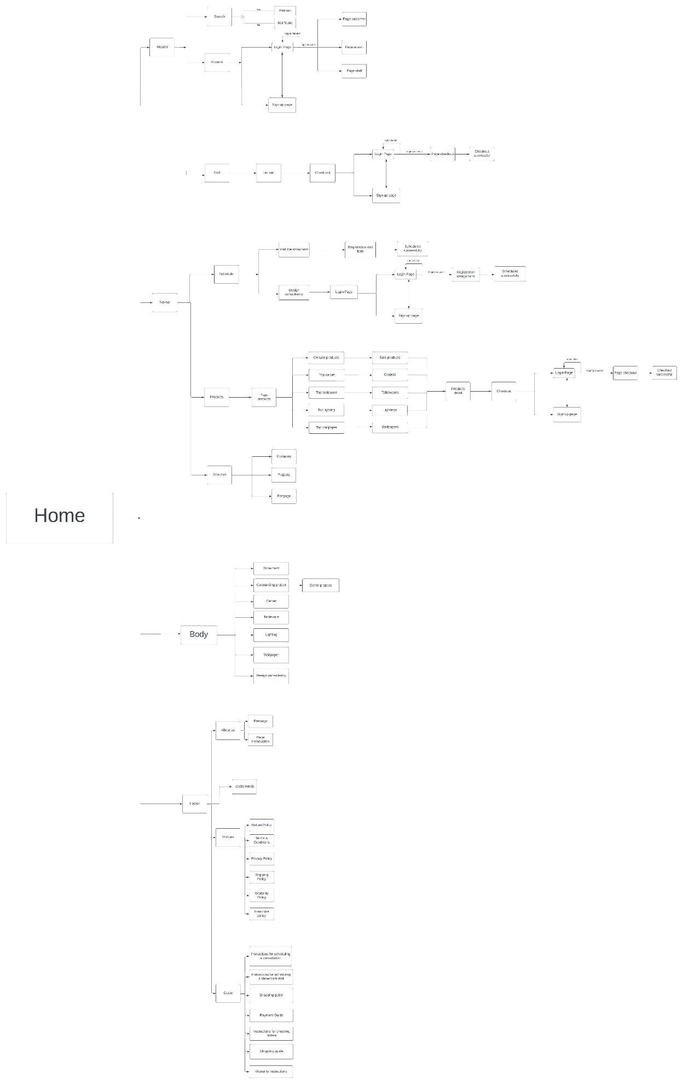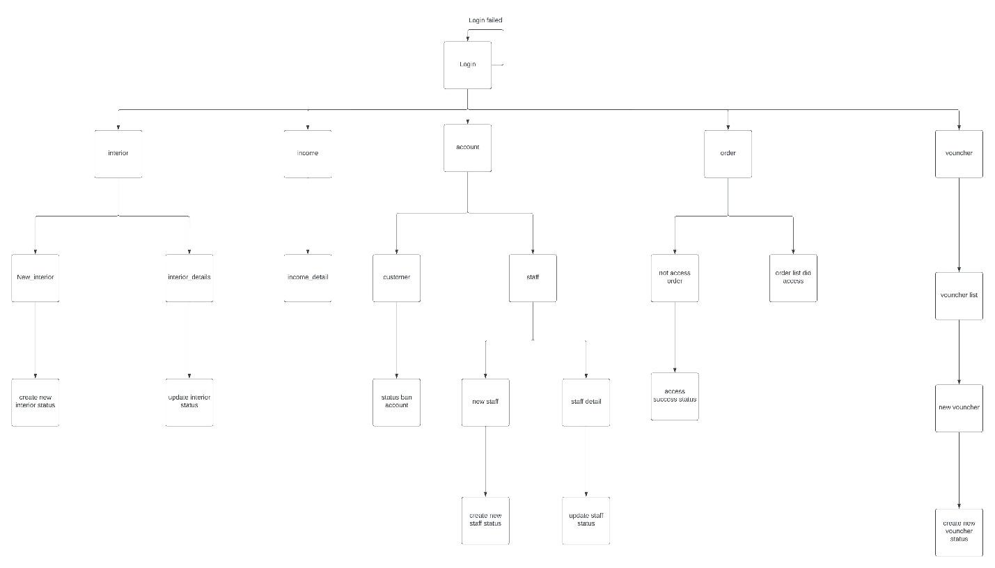





**6.8 Prototype**

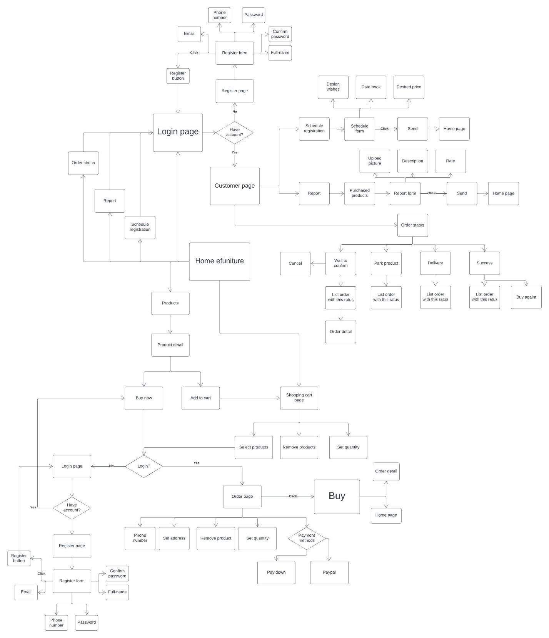

**7. Swimlane**

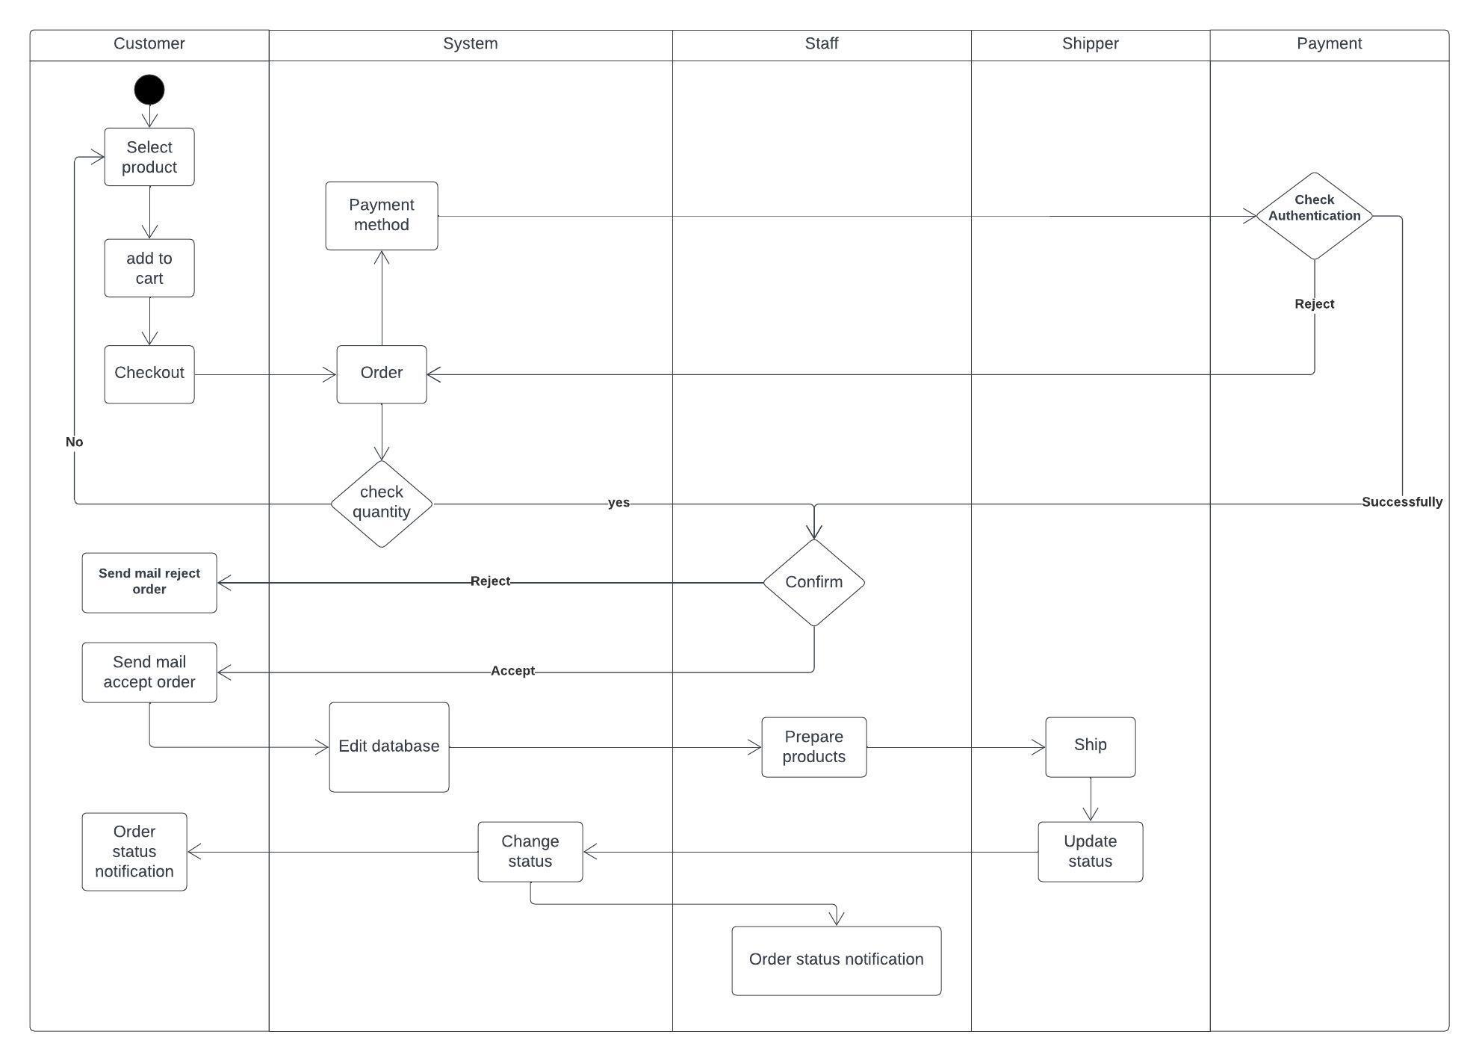

**8. State machine**

* **Report and buy previously purchased items**

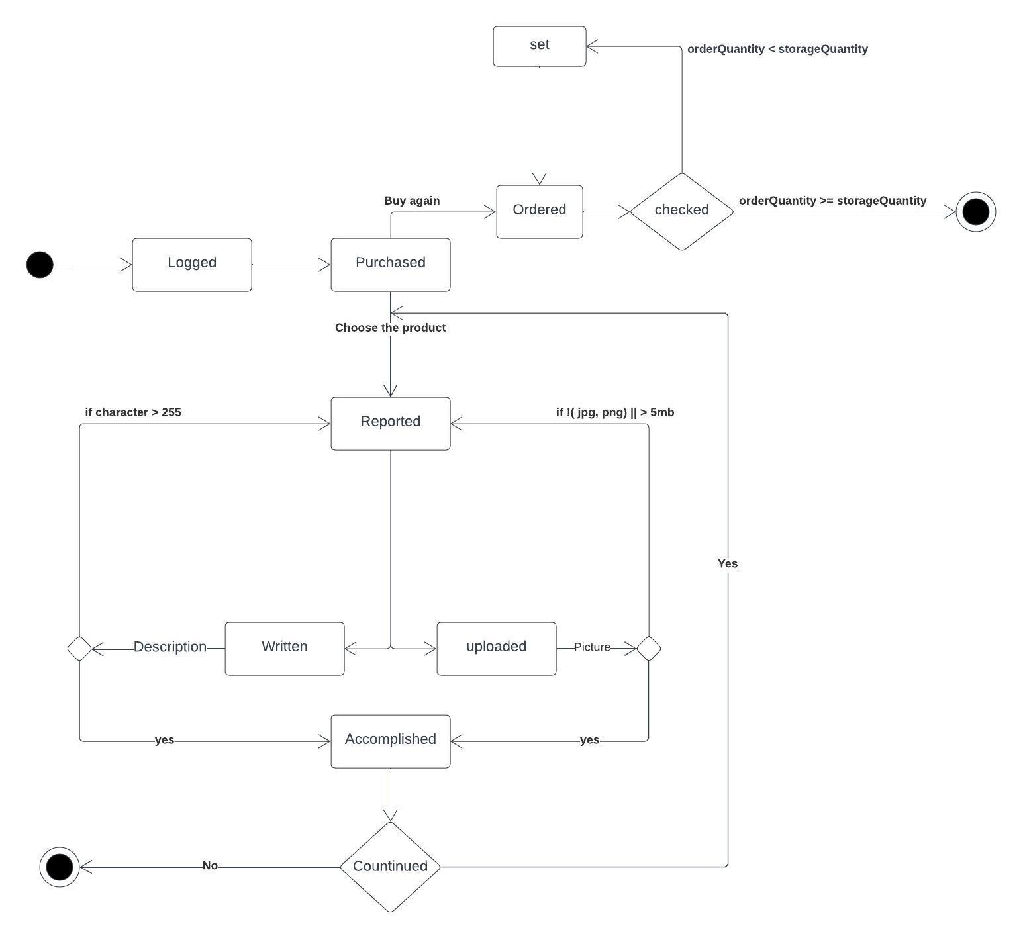

* **Buy products**

Untitled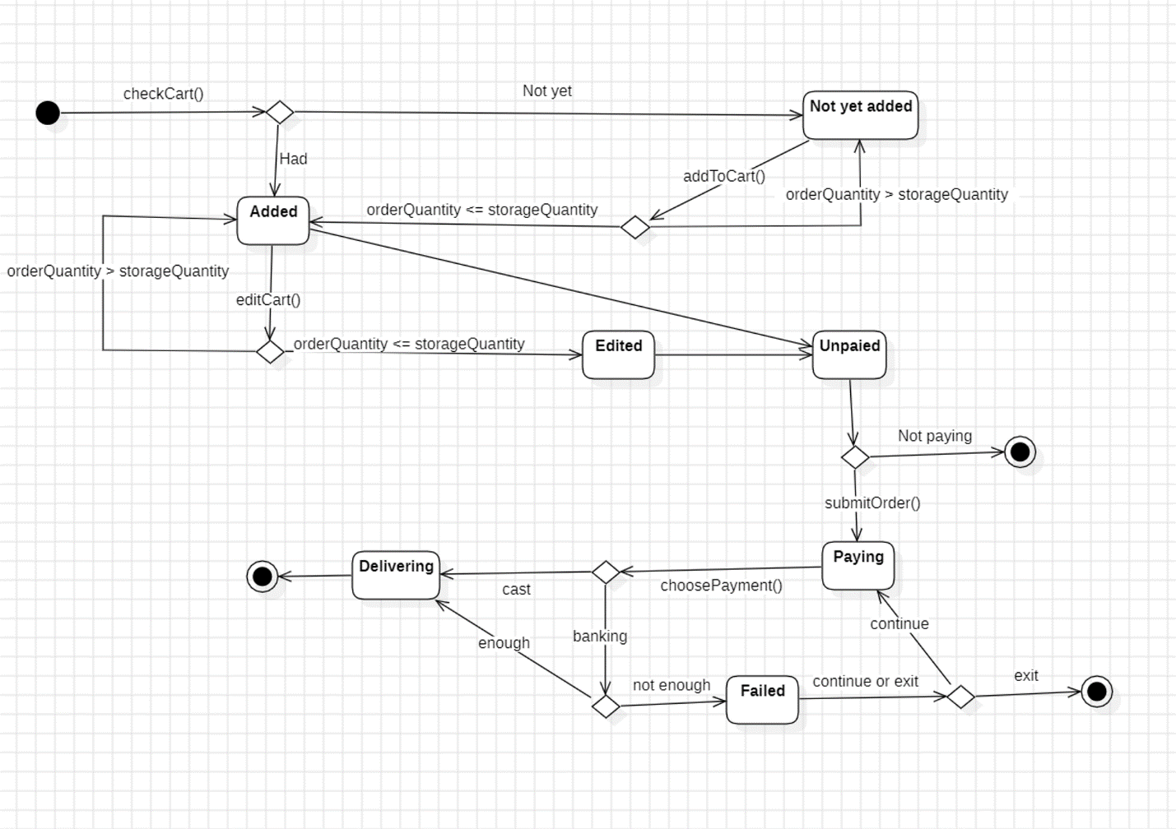

**9. Sequence diagram**

* **Nguyen Anh Huy - Order**

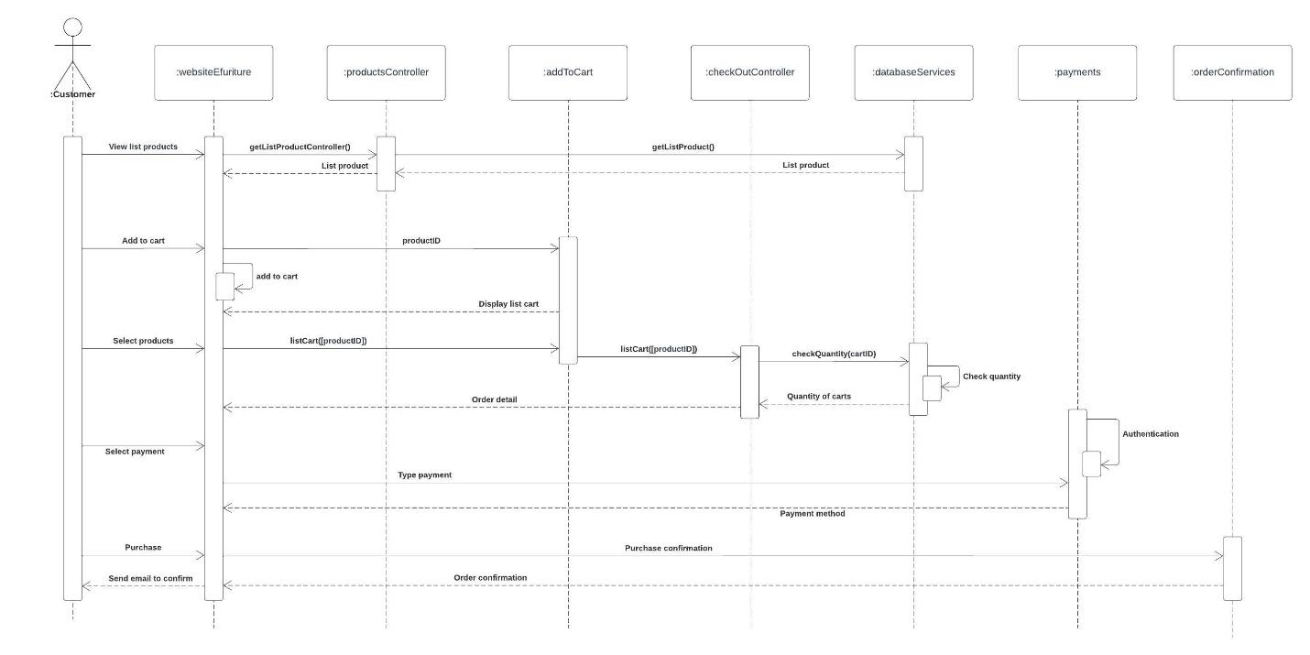

* **Nguyen Viet Hoang - Accept order**

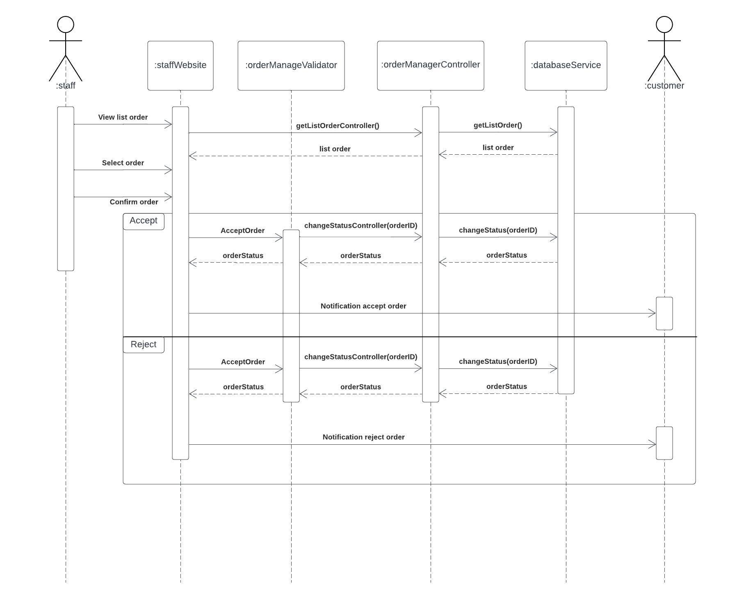

* **Nguyen Le Phuong Nam - Interface with cart**

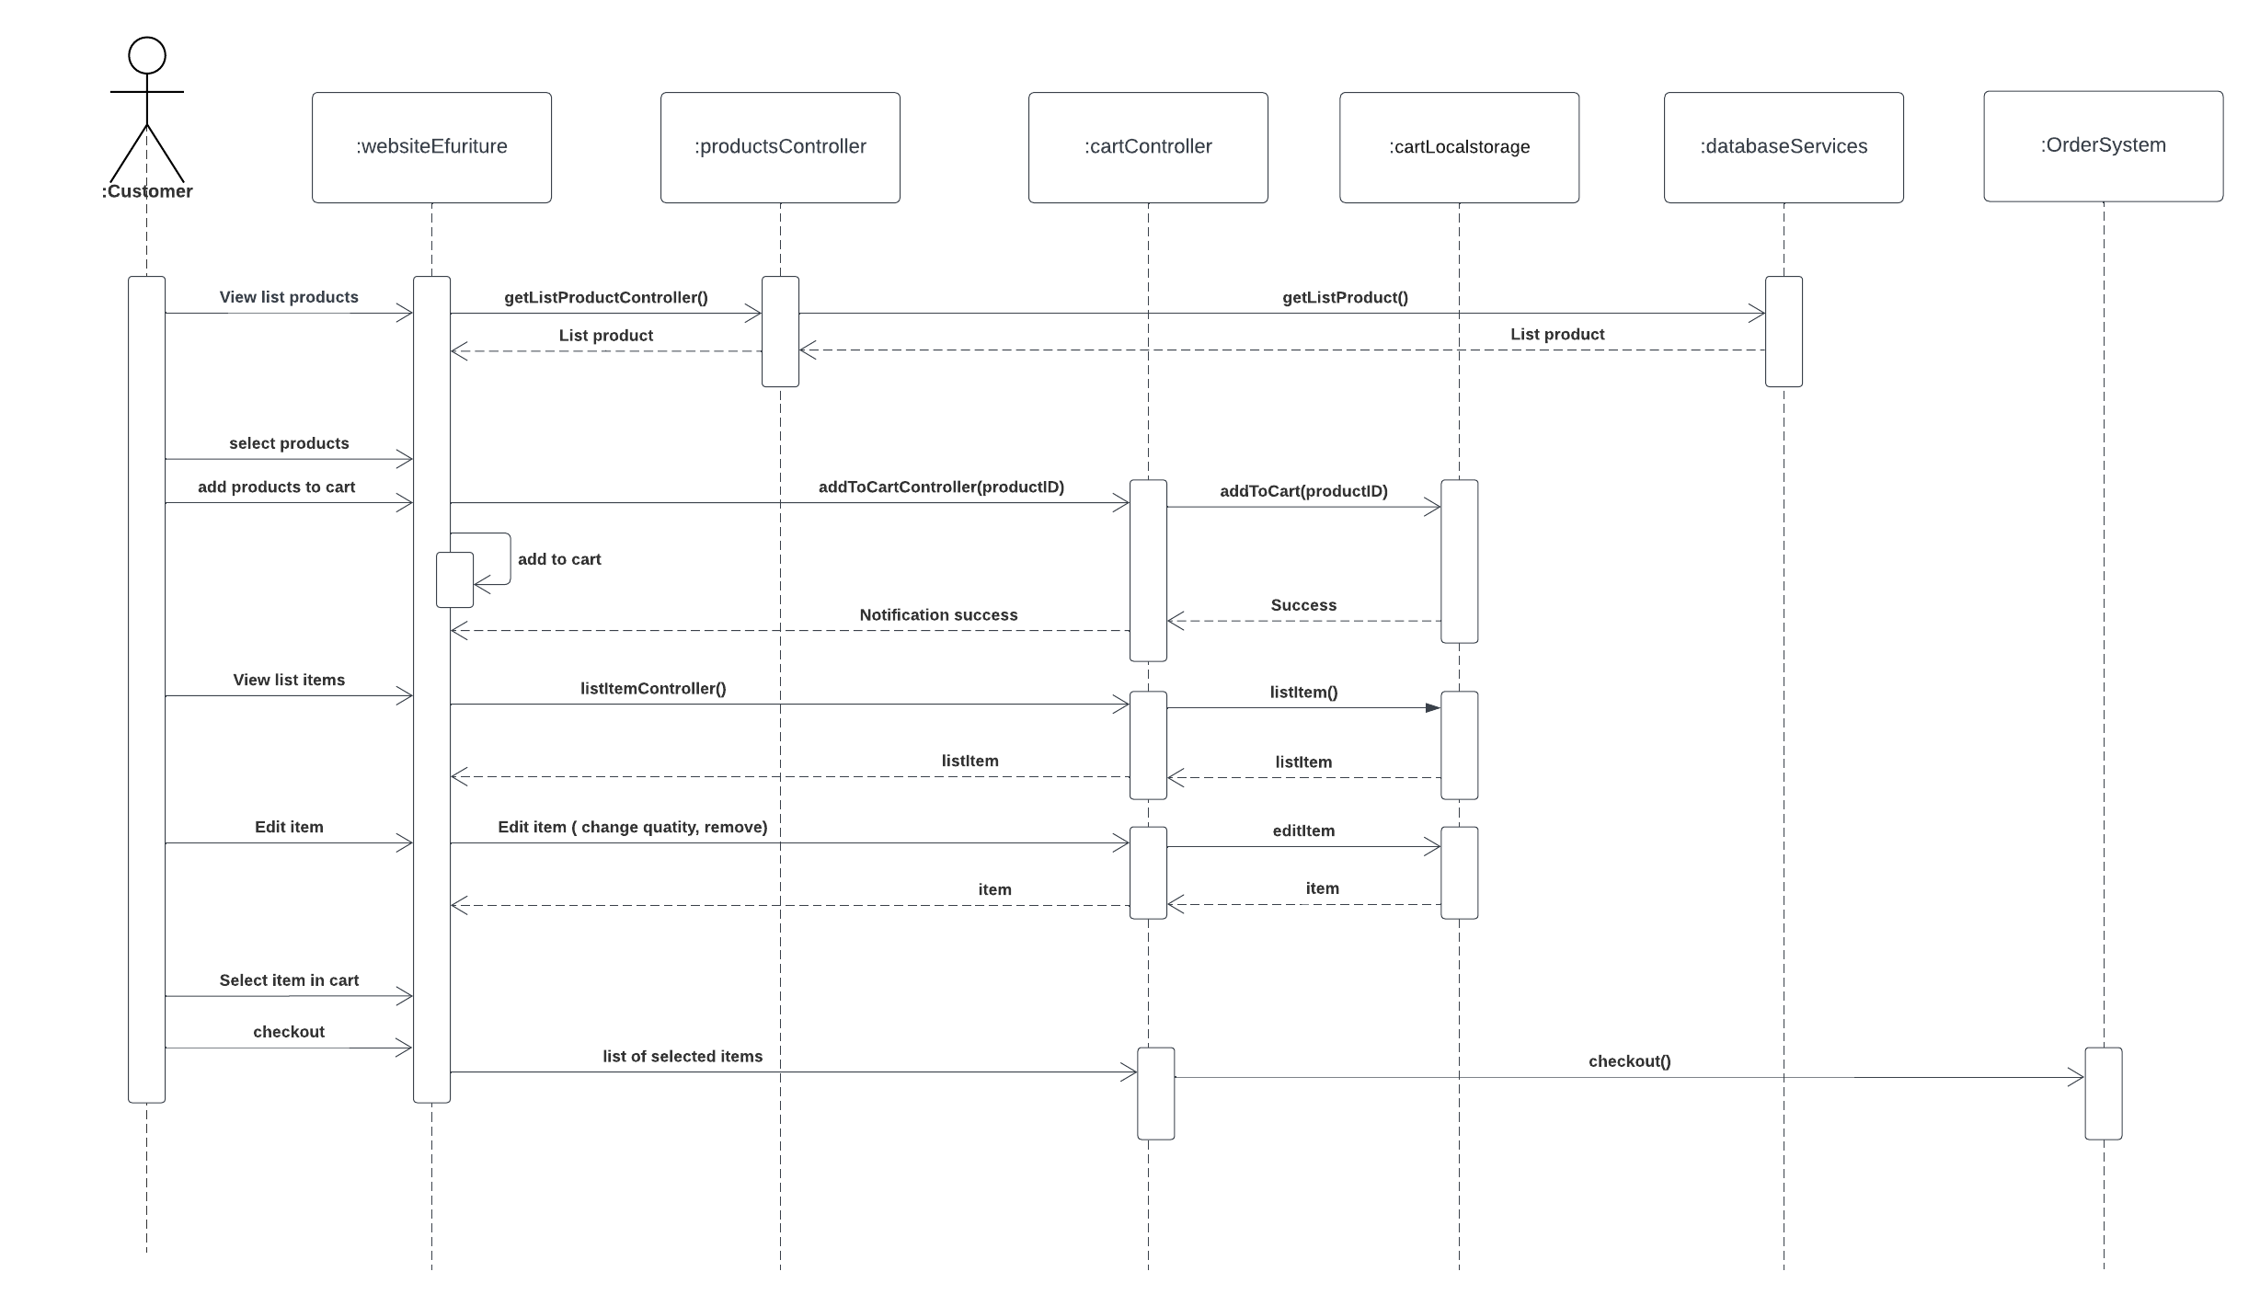

* **Do The Hieu - Manage accounts**

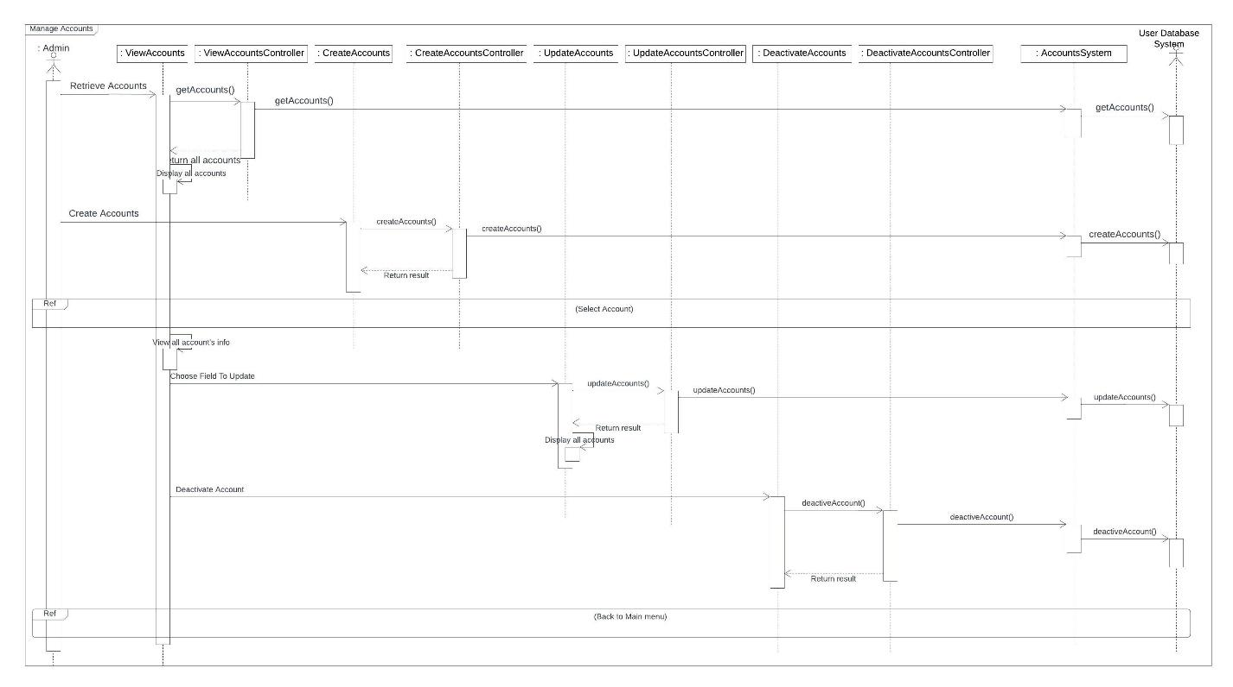

* **Nguyen Hoang Dat - Manage user’s report**

Untitled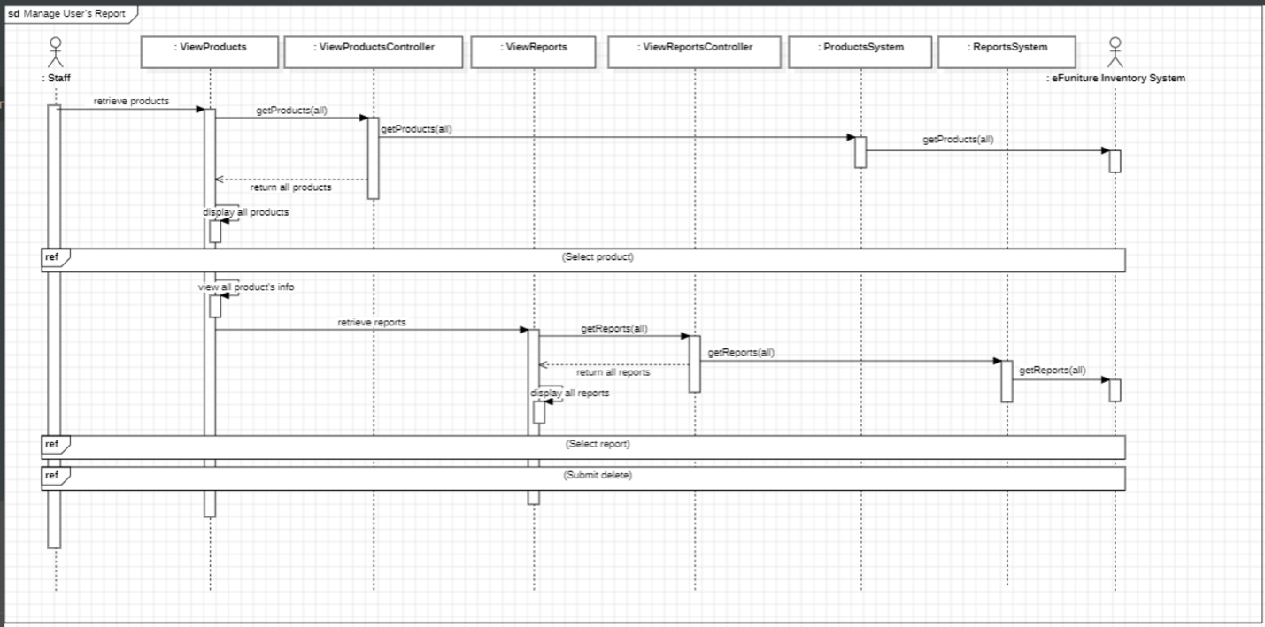

**10. Class diagram**

* **Nguyen Anh Huy - Order**

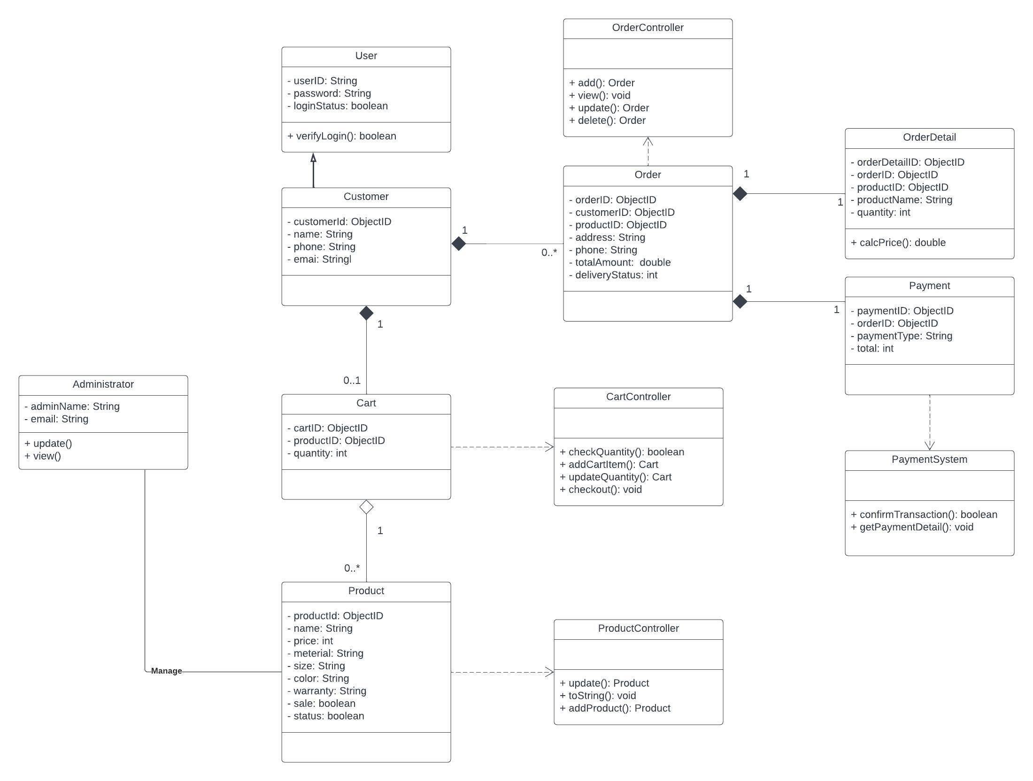

* **Nguyen Le Phuong Nam - Interface with cart**

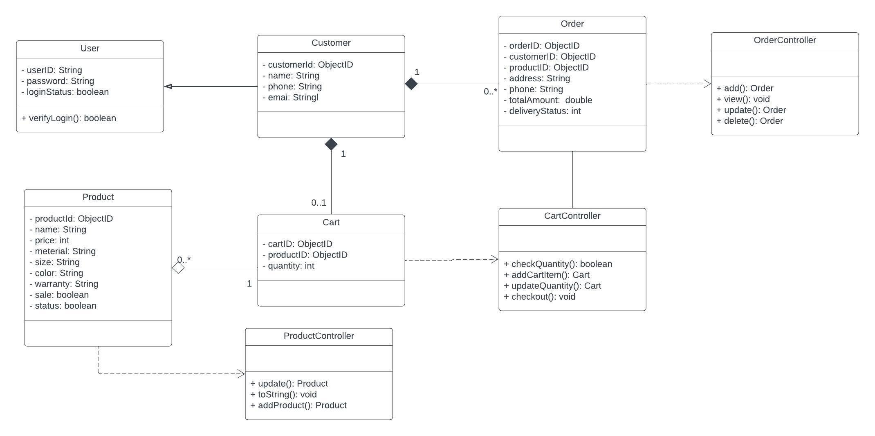

* **Nguyen Viet Hoang - Accept order**

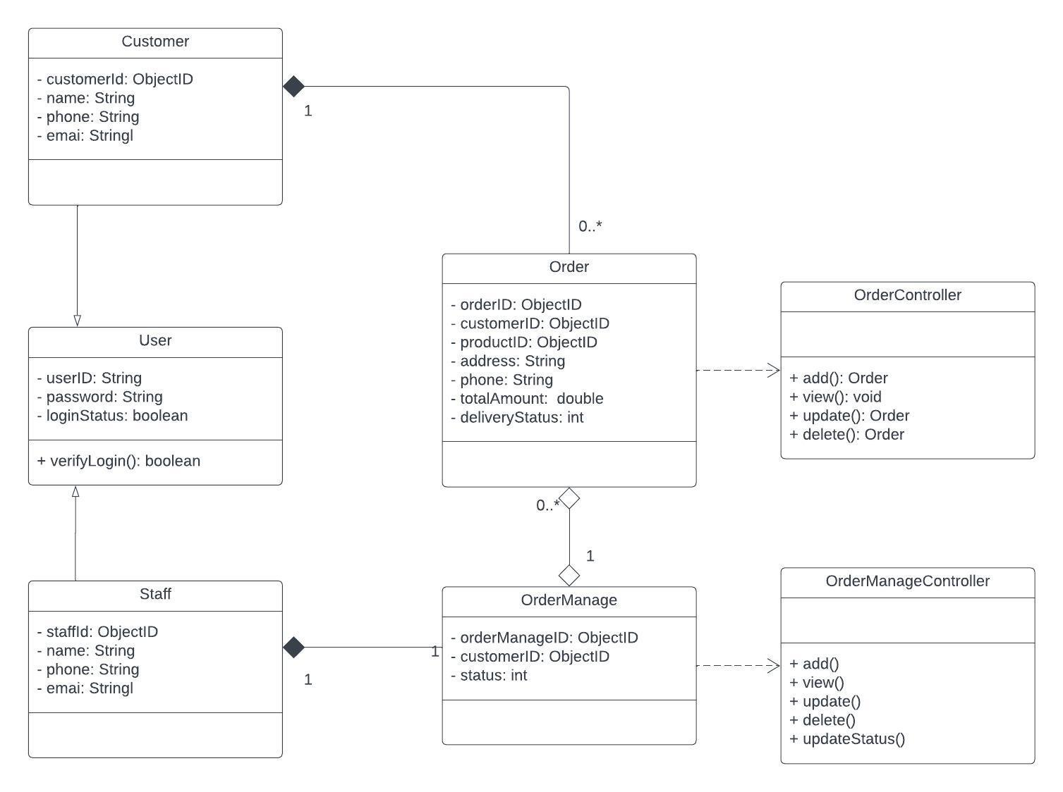

* **Nguyen Hoang Dat - Manage user’s report**

Untitled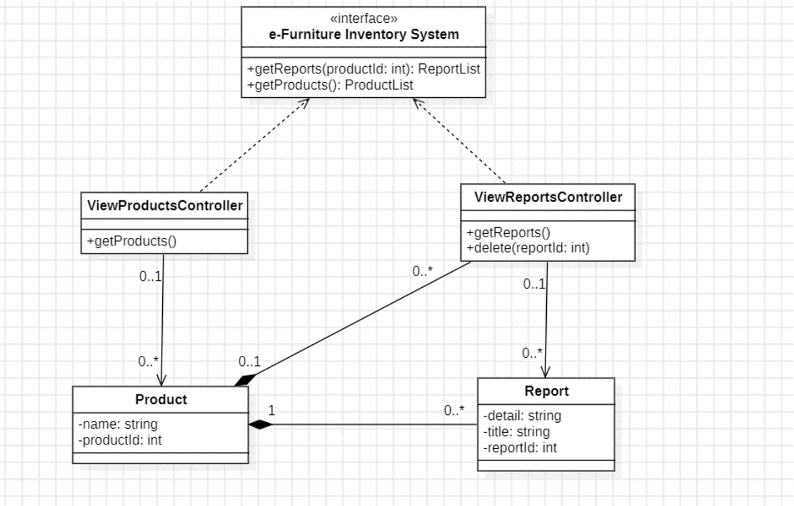

* **Do The Hieu - Manage accounts**

